Case Study by Jex De Los Santos
on September 2, 2026

Tools Used

- Google Sheets
- Python
- PostgreSQL
- DBT
- Github
- PowerBI
- MS Powerpoint

Business problem

The problem is casual riders are not interested in getting annual memberships.

The task is to find insights on how casual riders are different from annual members and use them to create a plan to convert casual riders into annual subscribing members.

About the data

The data is originally from Divvy accessed from their Amazon AWS:
https://divvy-tripdata.s3.amazonaws.com/index.html

The data does not contain Personally Identifiable Information and it is officially owned by the City of Chicago. Given that the data is of type first-party data, the data credibility is strong. Additionally, the data integrity is fixed by cleaning later on in this document.

The data selected to analyze is from August 2025 up to June 2026, each month contained in a separate zip file. Each zip file contains the data in .csv format.

Upon examining the data in a spreadsheet, it contains empty values for the station columns.

Data cleaning

Using Python, I:
- Removed the null values
- Removed the duplicates
- And combined the 12 .csv files into 1 .csv file

Here is the link to Kaggle, the Python notebook I used to manipulate the data:

https://www.kaggle.com/code/xooooo/cleaning-bike-data

The data is now combined into 1 .csv file. The file size is 781MB.

The csv data is then ready to be uploaded into the following PostgreSQL table.

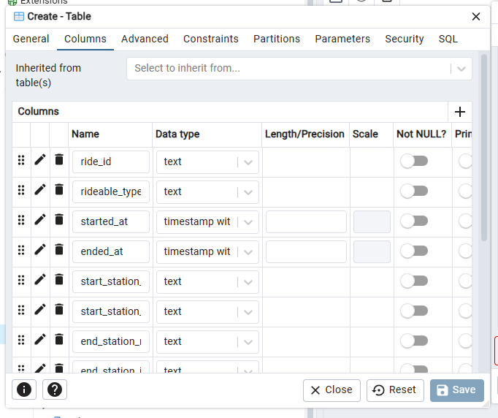

After importing the data into PostgreSQL, the data is ready to be queried.
The data is then queried from the PostgreSQL database using DBT as connector. These DBT SQL queries are models where each query creates a View. The queries I used that created the PostgreSQL views is available here in Github:

https://github.com/jexdls/data-analysis/tree/main/bikers_analysis/models/example

Upon examining the data in PostgreSQL views, I found out that the column started_at has values that are earlier than ended_at. This is not possible since you can only end a trip at a date time later than the start date time. This created a problem where trip_durations have negative values. Since, trip_duration pertains to how long the ride lasted, it should not be possible to have a negative value so I investigated further.
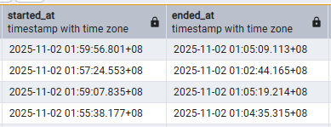

Another problem was found where thousands of records has trip_durations of less than 1 second. Which should not also be possible.

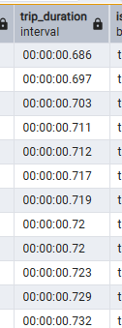

To improve data integrity, I thought I have to solve these problems first and delete rows. If I’m going to delete rows whose trip_duration is not valid, what trip_duration value should be considered valid? Negative trip_durations are surely not valid. Even millisecond trips are not valid, but where should I stop? Are 1-second or 5-second trips valid or should be deleted? While looking for the limit, I noticed that some start_stations and end_stations are the same for trips that lasted less than a minute. However, the start_station being the same as end_station is not enough of a basis to say that the record is not valid because there are records that lasted less than a second whose start_stations are not end_stations.

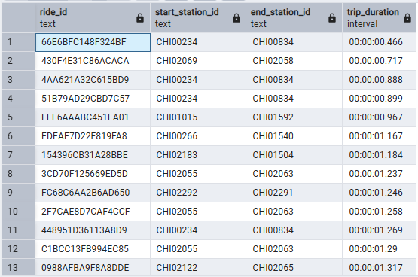
Upon investigating further, the following query revealed the reason. I first looked at trips that started and ended at different stations to rule out trips that started and ended at the same stations.

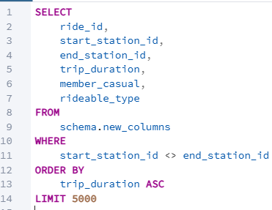

It was revealed that these extremely short trips are of type electric_bike which could mean that electric_bikes have a bug that registers these extremely short trips into the database.

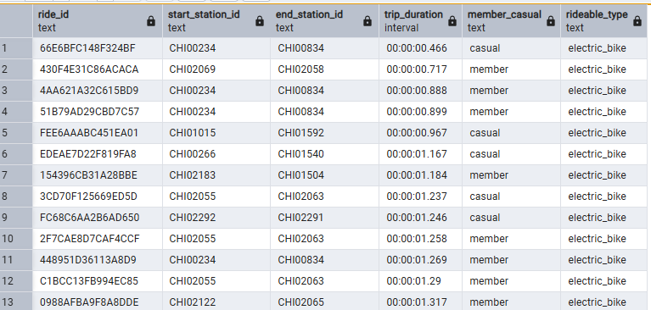

For the other type of bike, when the trip_duration for classic_bikes are sorted from least, the lowest trip_duration is 01:00:087, which is at 1 minute mark. This means that classic_bike trips are more reliable than electric_bikes.

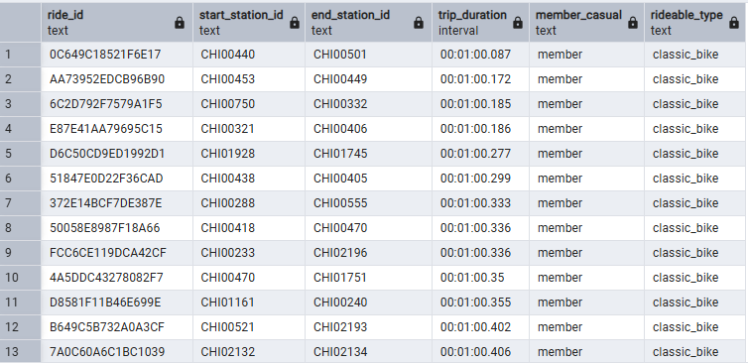

To further investigate, the following query was made to look at the minimum trip_duration for each bike type.

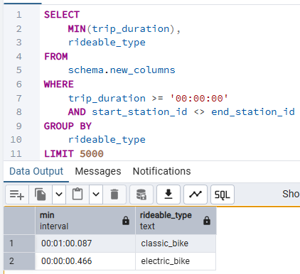

It was revealed that the minimum trip_duration for electric_bike are 0 second trips, which may be concluded that valid trips should instead start from the minimum trip_duration for classic_bikes which is 00:01:00.87 which is more reliable. To fix the data integrity, I deleted all the records that has a trip_duration of less than 00:01:00.87 because they aren’t reliable.

Insights and Findings

After all the cleaning, the data is ready for visualizing. Through Power BI, the visualizations were created.

To see the summarized findings ready for a presentation please visit:

https://docs.google.com/presentation/d/1BUnsha_8Fg4xy7TfsN-ir0CvqqwQb5Ry/edit?usp=sharing&ouid=102297499526937147407&rtpof=true&sd=true

The following examines the findings in greater detail.

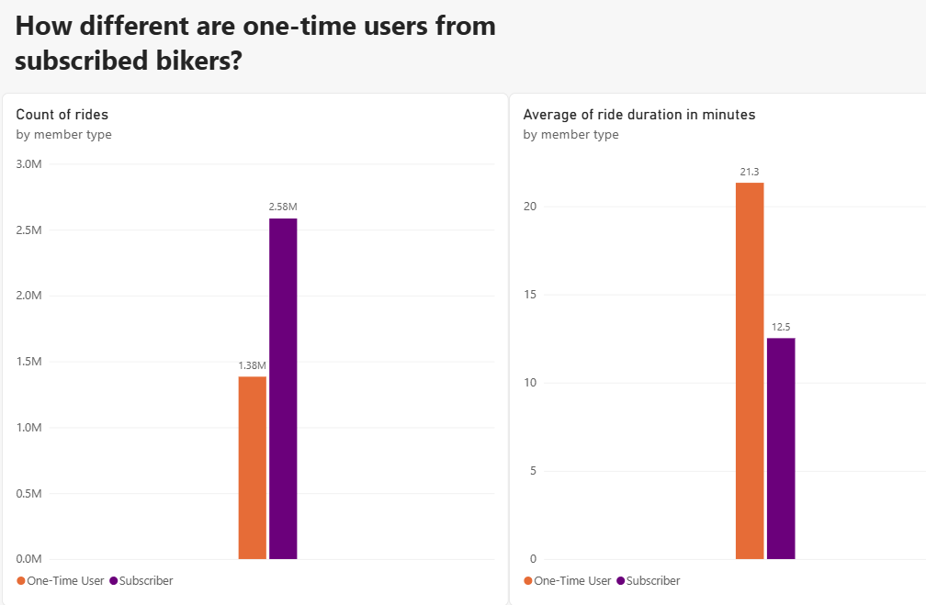

How different are one-time users from subscribed bikers? According to the data, 2.58M of bikers are from subscribed bikers. The casual bikers are almost half of the subscription bikers with 1.38M bikers. Although there are more subscription bikers, casual bikers tend to have longer rides than subscription bikers. They take an average of 21.3 minutes of riding while the subscribed bikers take almost half of these bikers having an average of 12.5 minutes ride.
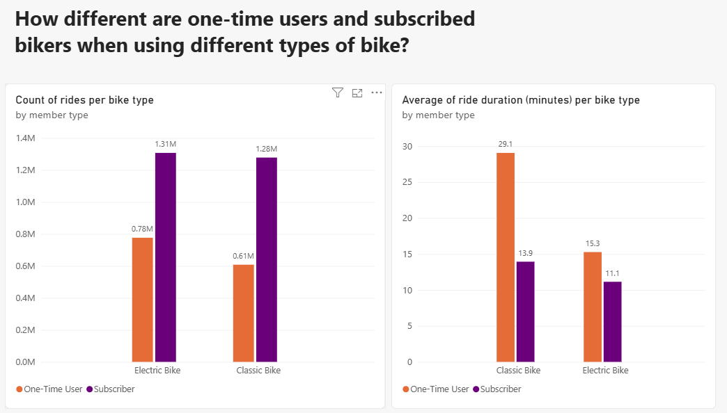
How different are one-time users from subscribed bikers when using different types of bike? There’s no significant difference for this. Both casual bikers and subscription bikers have a longer average ride on classic bikes. Additionally, there’s more number of rides for electric bikes than classic bikes.

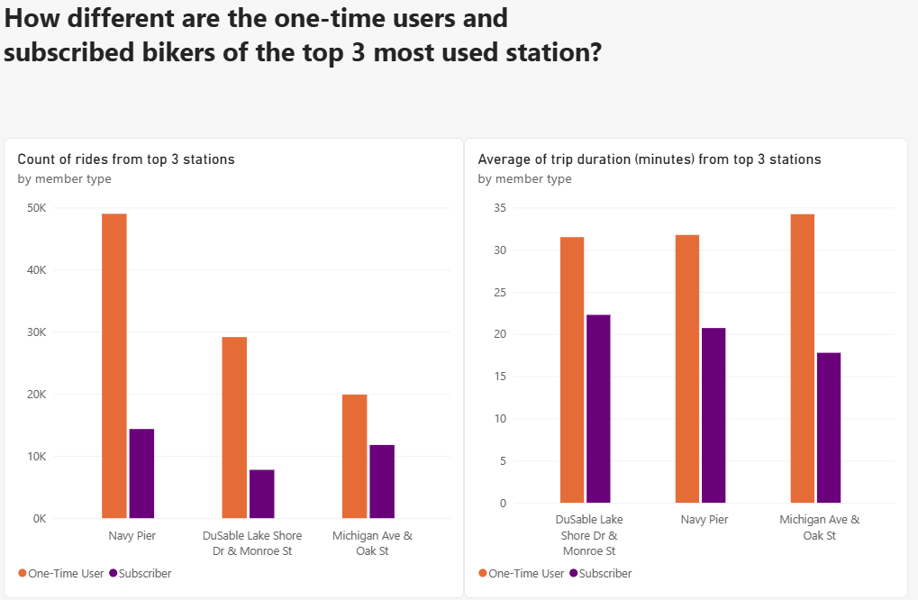
How different are the one-time users and subscribed bikers who start from the top 3 most used stations? One-time users have more number of rides as well as have longer rides than subscribed bikers in the top 3 stations most rides start at which are Navy Pier, Michigan Ave & Oak St., and DuSable Lake Shore Dr & Monroe St.

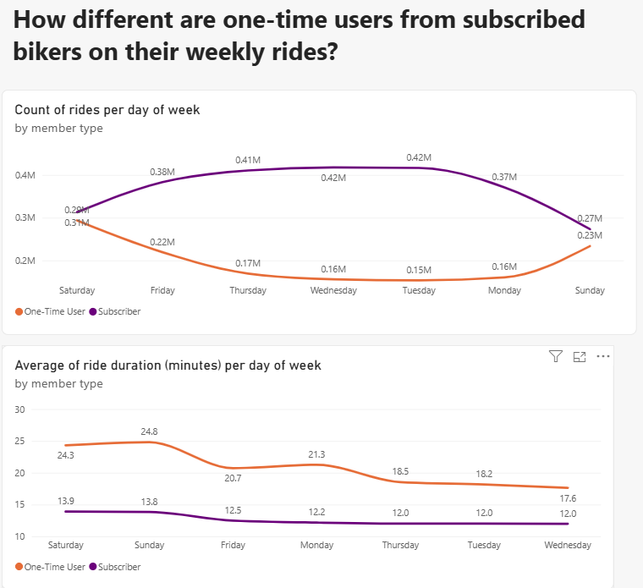How different are one-time users from subscribed bikers on their weekly rides? During weekdays, there is an increase of rides from subscribed bikers, and a decrease of rides from one-time users. However, there is an increase of one-time rides during the weekends. Additionally, both one-time users and subscribed bikers have longer rides during the weekends.

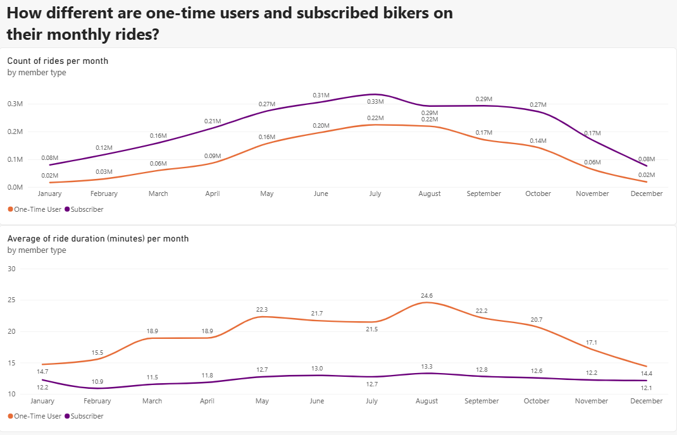
How different are one-time users and subscribed bikers on their monthly rides? There is an increase of rides from May to October. Additionally, one-time users have longer rides from May to October while subscribed bikers have a sustained duration of rides throughout the year.

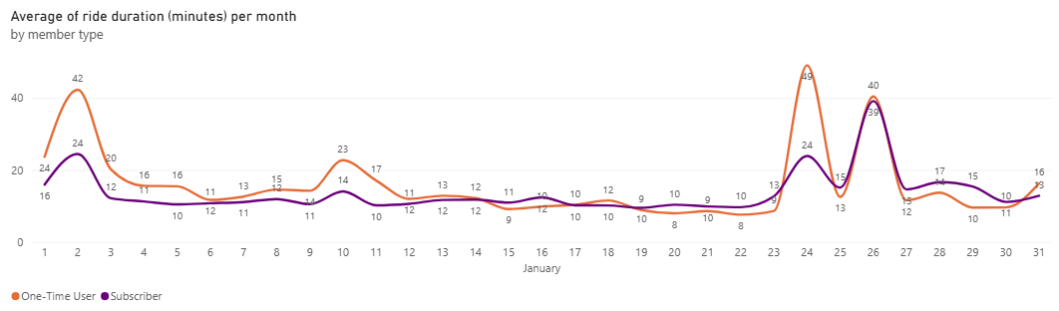
For a detailed view on January, there is a sudden increase of rides having longer duration on January 2. This is likely caused by the celebration of New year.

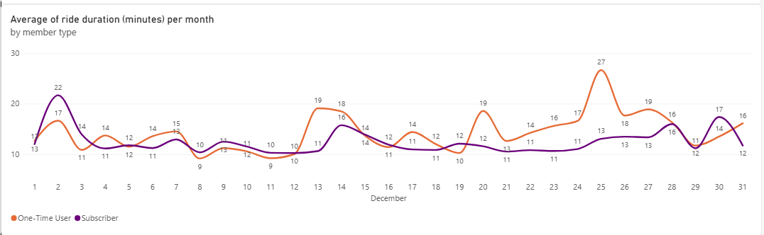
For a detailed view on December, there is also a sudden increase of one-time rides having longer duration on December 25. This is likely caused by the celebration of Christmas. On the other hand, subscribers have a sustained duration of rides throughout the day.

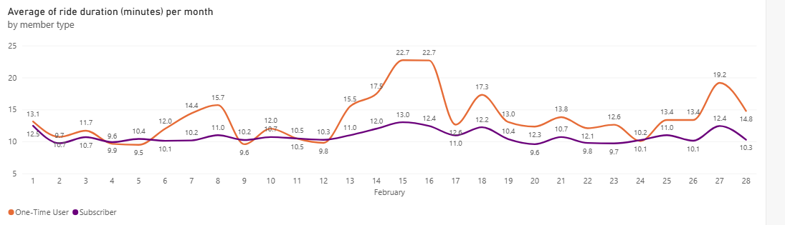
For a detailed view on February, there is also a sudden increase of one-time rides having longer duration on February 14, 15, and 16, which may be caused by the celebration of couples during Valentines day. On the other hand, subscribers have a sustained duration of rides throughout these days.

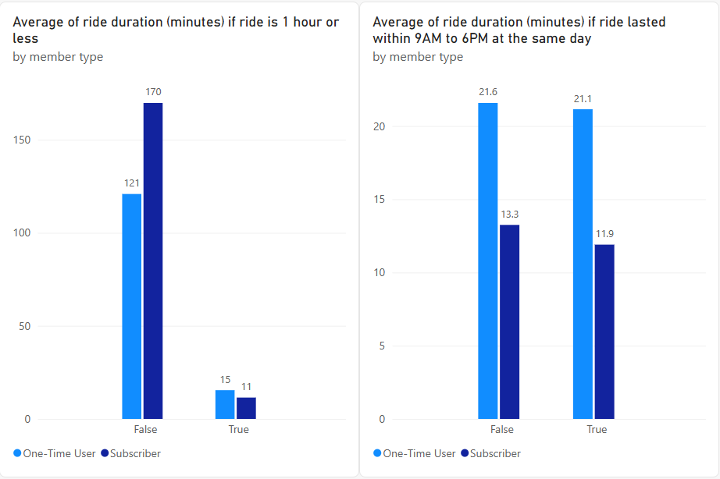

Furthermore, subscribers have longer rides for rides that take more than an hour while one-time users have shorter rides for rides that take more than an hour. This can speak of subscribers making the most out of their subscription while one-time users appear to save for long rides given that one-time users tend to want longer rides.

Next, one-time users have longer rides for rides that take 1 hour or less while subscribers have shorter rides for rides that take 1 hour or less.

Lastly, one-time user tend to have longer ride duration whether rides are within 9AM to 6PM or not. There is no significant difference for these rides.

Conclusion

It can be inferred that the one-time users primarily use the bikes for leisure and want longer rides while annual members show a more routinized use of bikes and save for longer rides. This is useful for commuting, or even simply going to work.
Recommendation

Since one-time users may want longer rides for leisure it is recommended to create member-only offers that save them money for long rides during special days like Christmas.

Promote these offers in the top 3 stations Navy Pier, Michigan Ave & Oak St., and DuSable Lake Shore Dr & Monroe St. to maximize reaching one-time users.

Lastly, create enticing offers that are available for members during the weekends.

